**Section05 Building Ordering Micro services With Clean Architecture and CQRS**

**Notes:-**

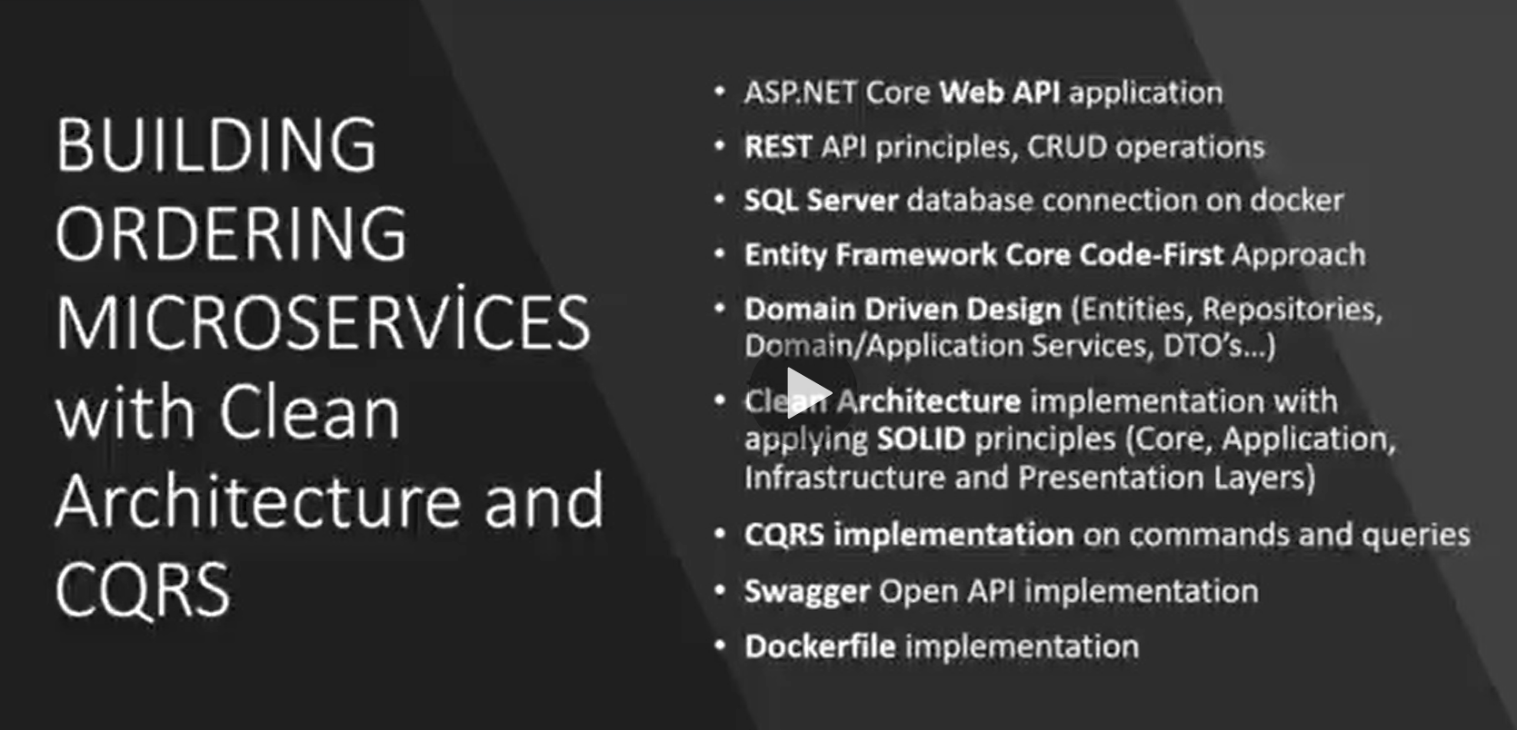

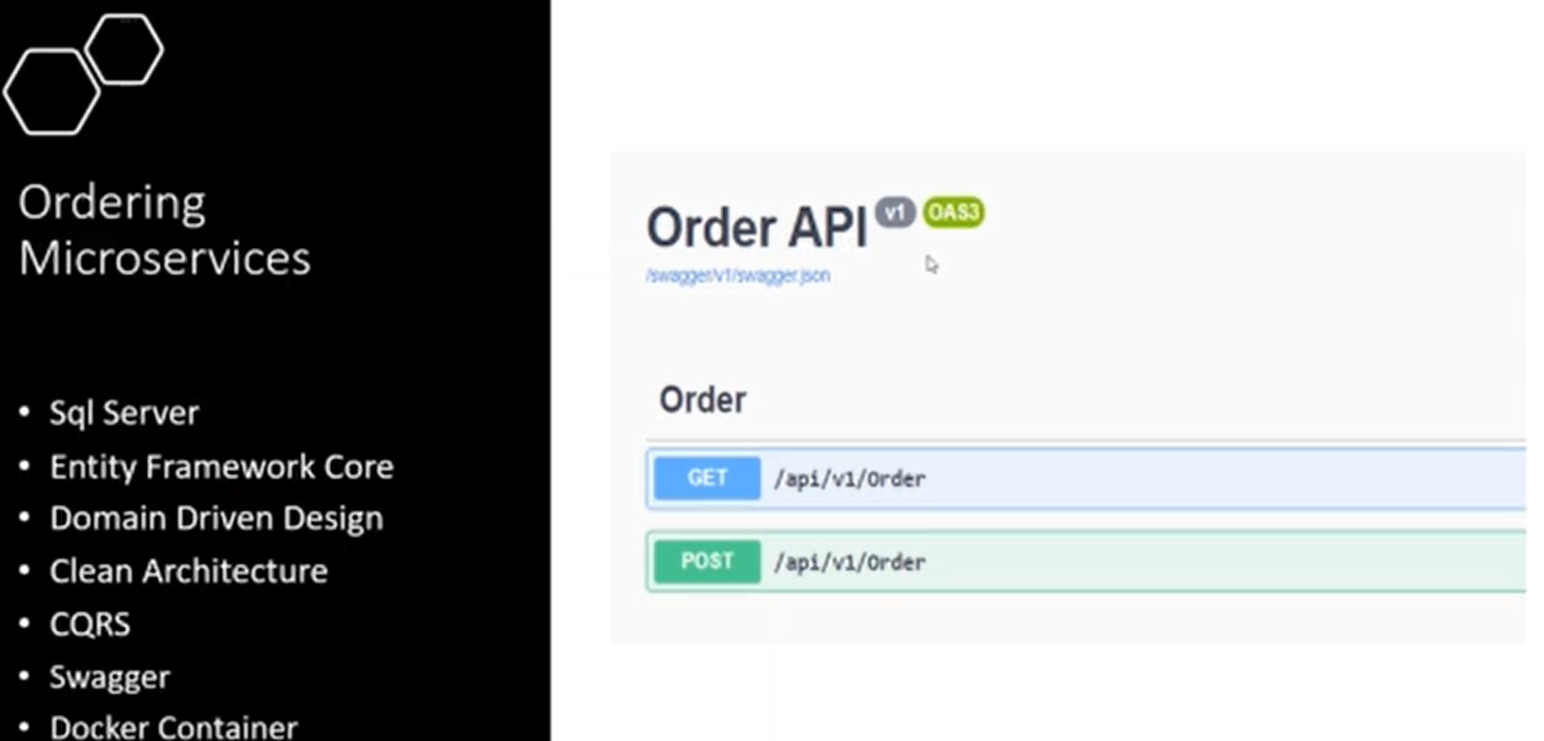

**Lesson01 Architecture of Micro services**

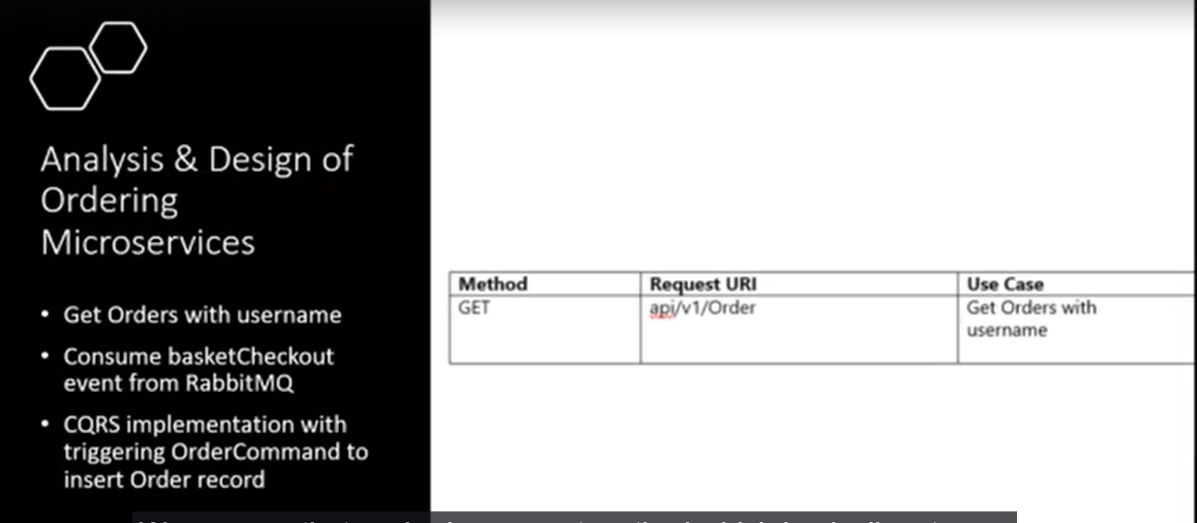

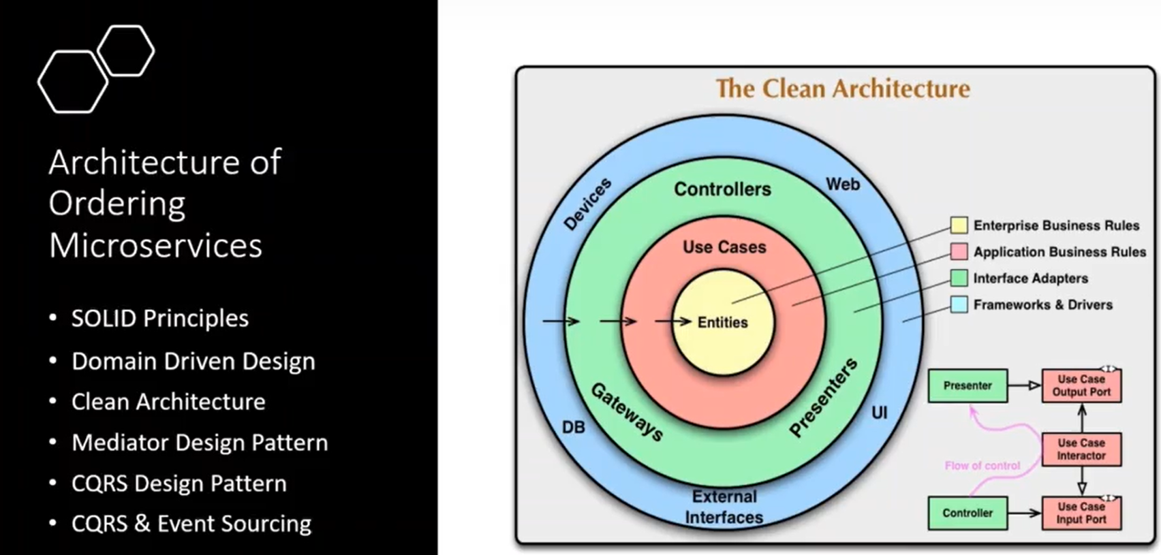

**Lesson02 SOLID Principle**

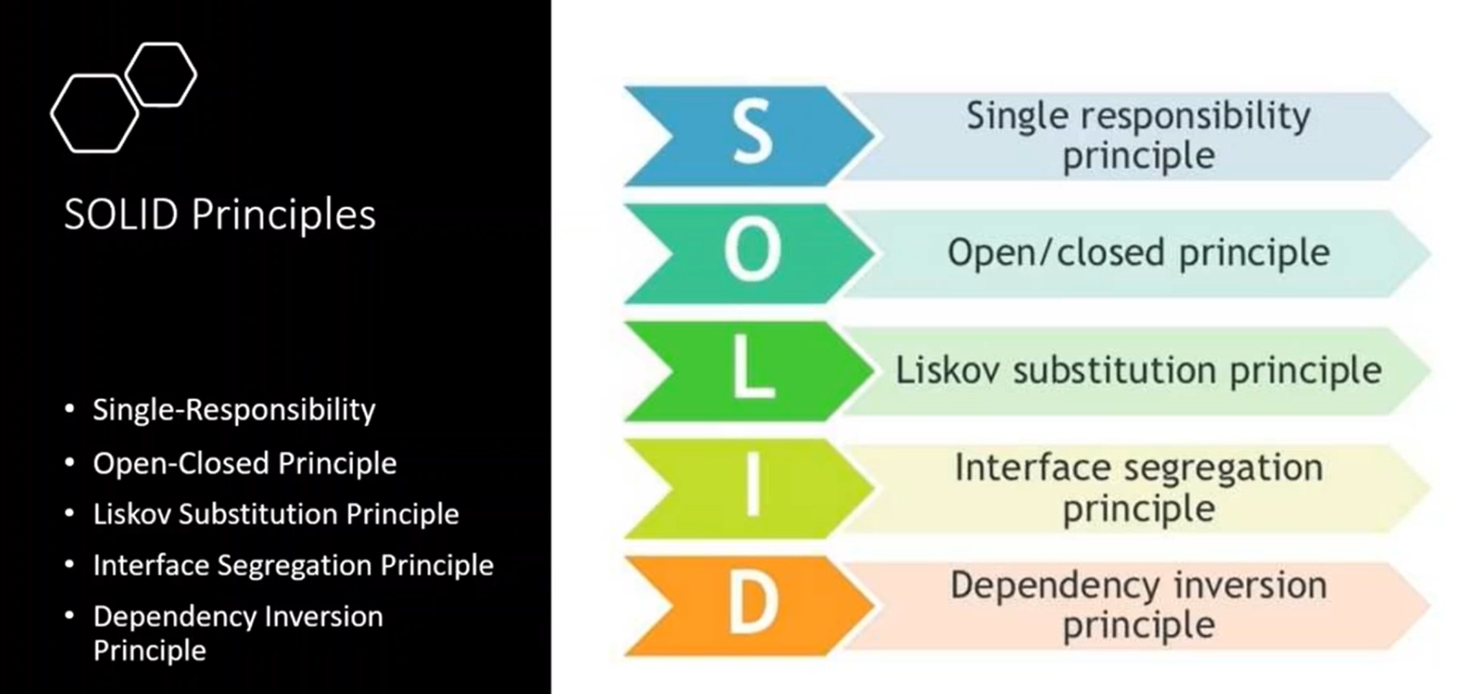

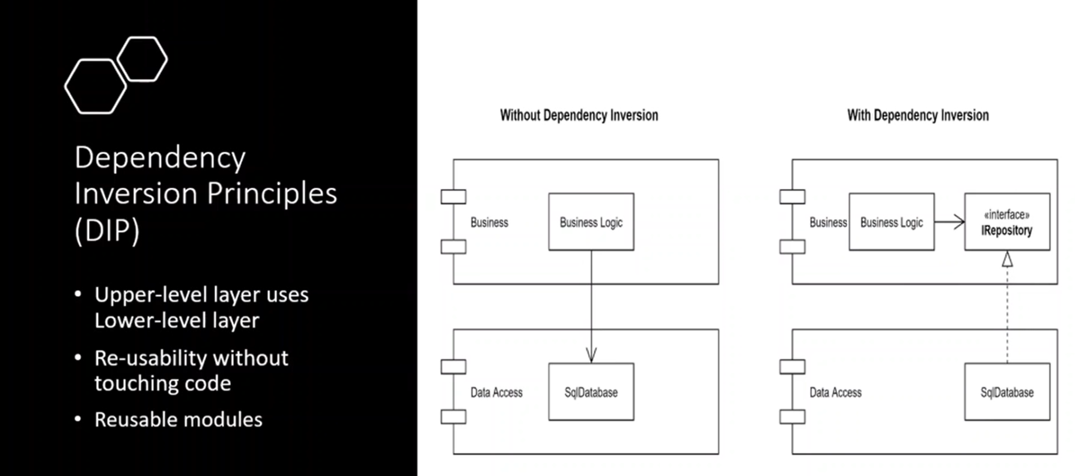

**With DIP you can change the data access layer as you want because the upper layer does not depend on the lower layer so its provide high flexibility.**

**Lesson03 Domain Driver Design**

**Notes:-**

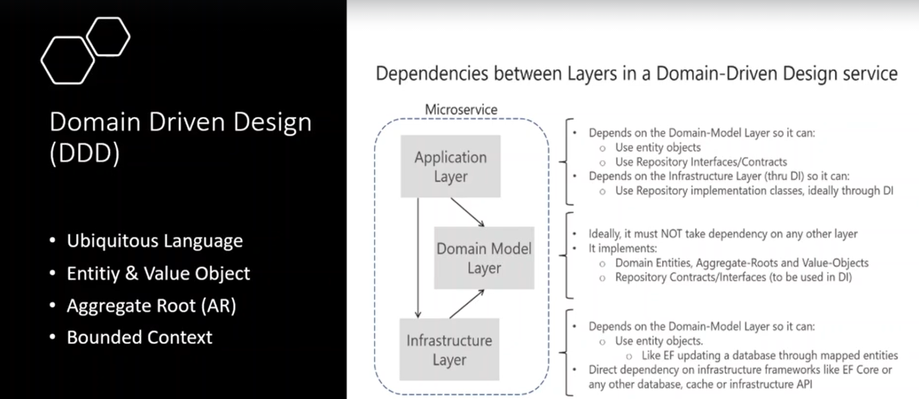

**Ubiquitous language: you must use the same language on all the 3 levels**

**Entities and value object: an entity with unique identifier and objects which can create entity which combine one or more entity**

**Aggregate Root (AR): is combination of multiple entities which associated with each other’s business, represent the aggregate the combination of the entities (communication between the entities) (or Domain)**

**Bounded Context: the systems should have sub domains and contains sub domains**

**When grouping the sub-domains its combining the bounded context**

**Like Commerce Sites is bonders context and it should be somewhat to some subdomains like your order management, customer management, stock management, David management ,**

**Lesson04 Other clean Architecture**

**Notes:-**

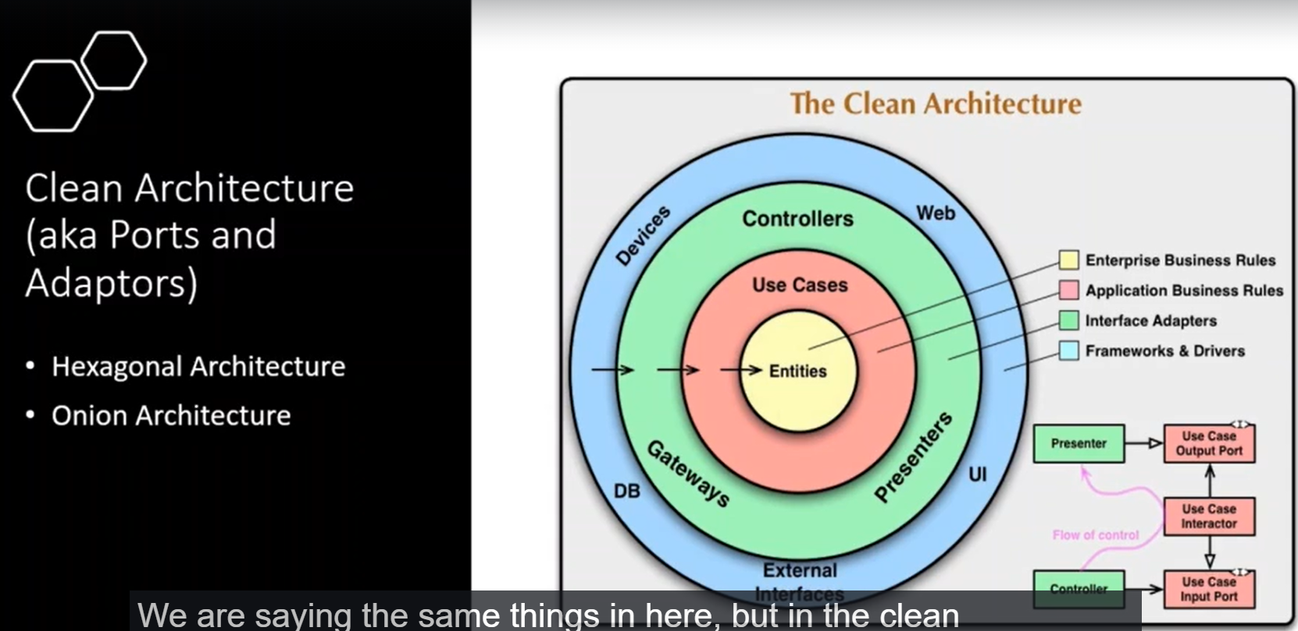

**1-Hexagonal Architecture:-**

**A-the lower layer should not depend on the upper layer, only the upper layer should depend on the lower layer**

**2-DDD Architecture:-**

**Which the Infrastructure and application layer should depend on the domain layer and the not like tree structure**

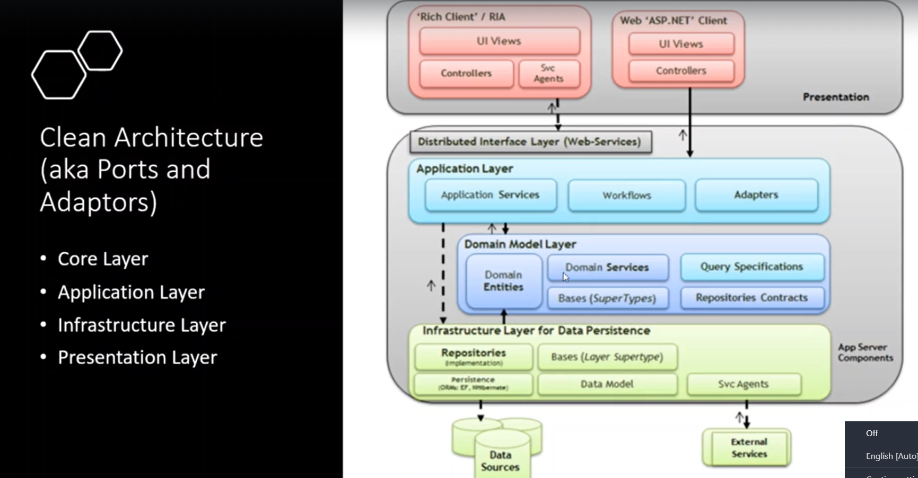

**Lesson05 CQRS (command query responsibility design pattern**

**Notes:-**

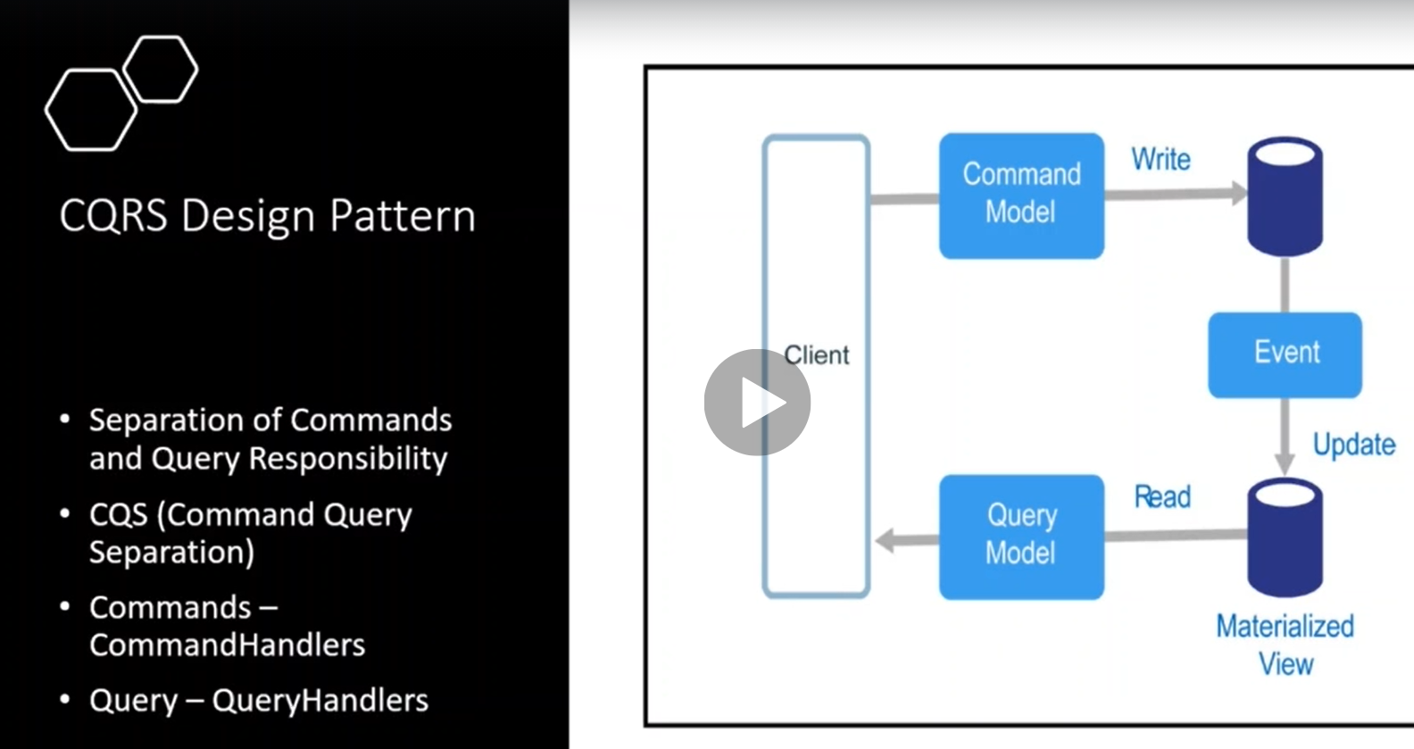

**1-CQRS represent to separation of commands and query responsibility**

**(The main idea is to separate the interfaces between our operation that reading the data and the operation that updating the data)**

**2-CQRS can make read operation on database 1 and write operation on database 2**

**3-the command is the only way to write to the systems by using command handler**

**4-the query is the only way to read to the systems by using query handler**

**5-the query handler called from event and the command handler called from event also and the event is inconsistent**

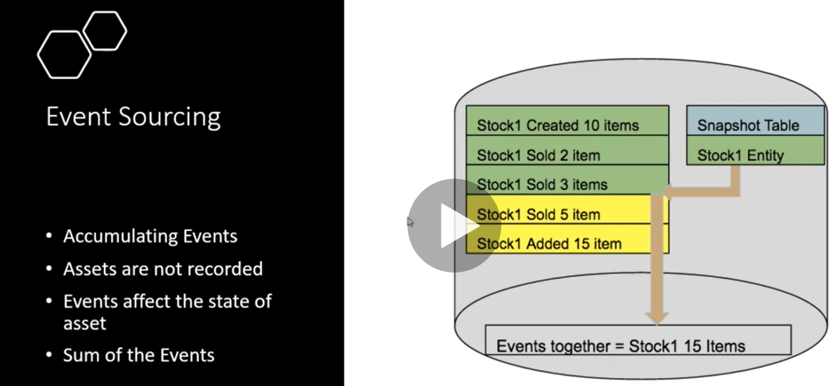

**1-CQRS depends on the event sourcing which depend on the accumulate events which store all the events.**

**2-so the idea from CQRS is to generate data from events not store data directly from the database**

**Lesson06 Code Structure CQRS and DDD Micro services**

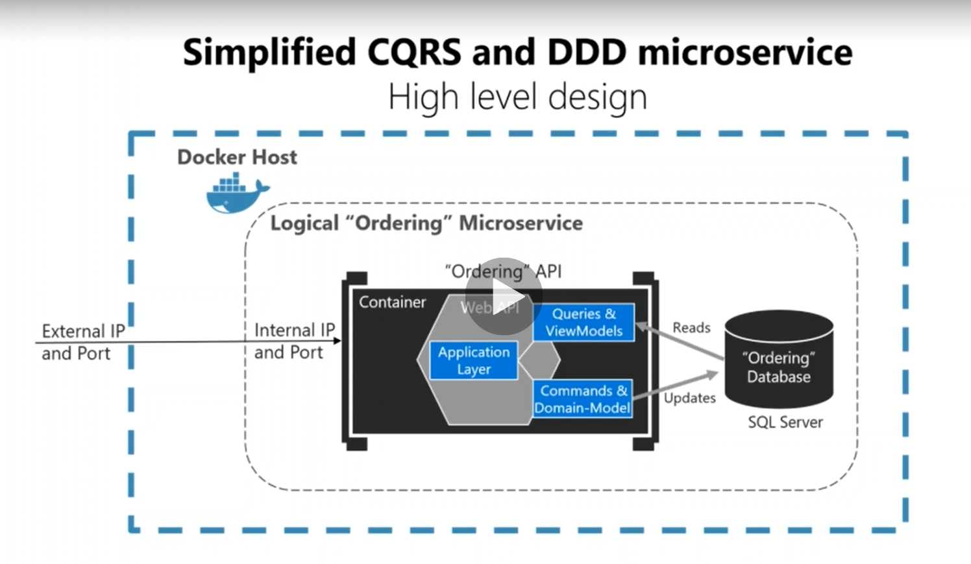

**Notes:-**

**1-Ordering API implements DDD architecture like the domain layer ,infrastructure layer , application layer**

**2-in the application layer we are separate the command and domain model and query and view models**

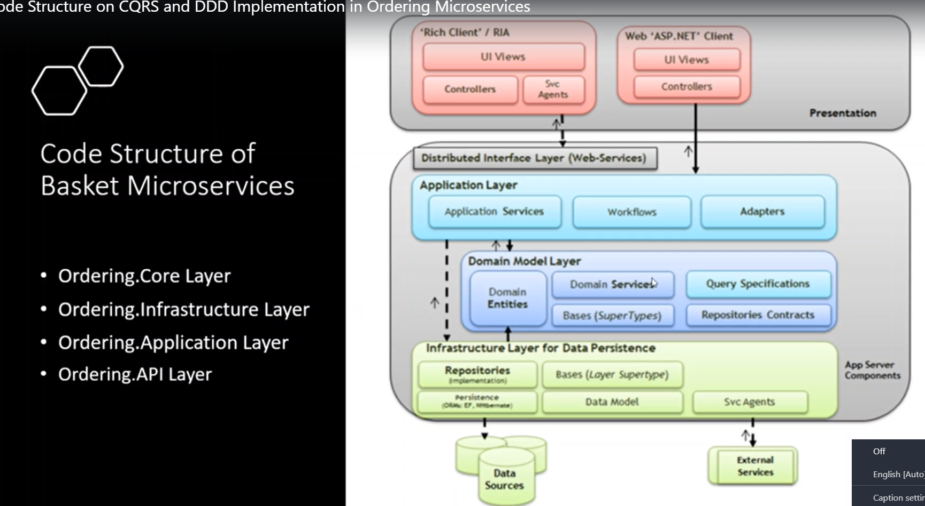

**1-Ordering-Infrastructure layer: which implement the CRUD operation with the database with repository objects**

**2-Ordering-Application layer: which communicate with the domain model layer with implement the CQRS that implement command and query segregation by using mediator**

**3-Domain Model layer: which we are grouping the business model into entities inside the domains and grouping by bounded context**

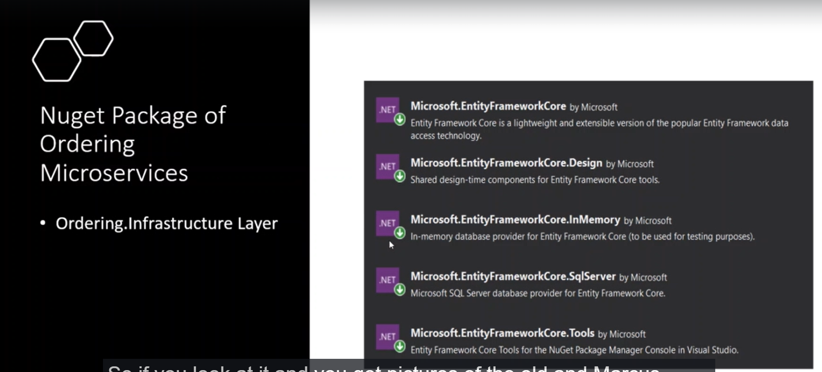

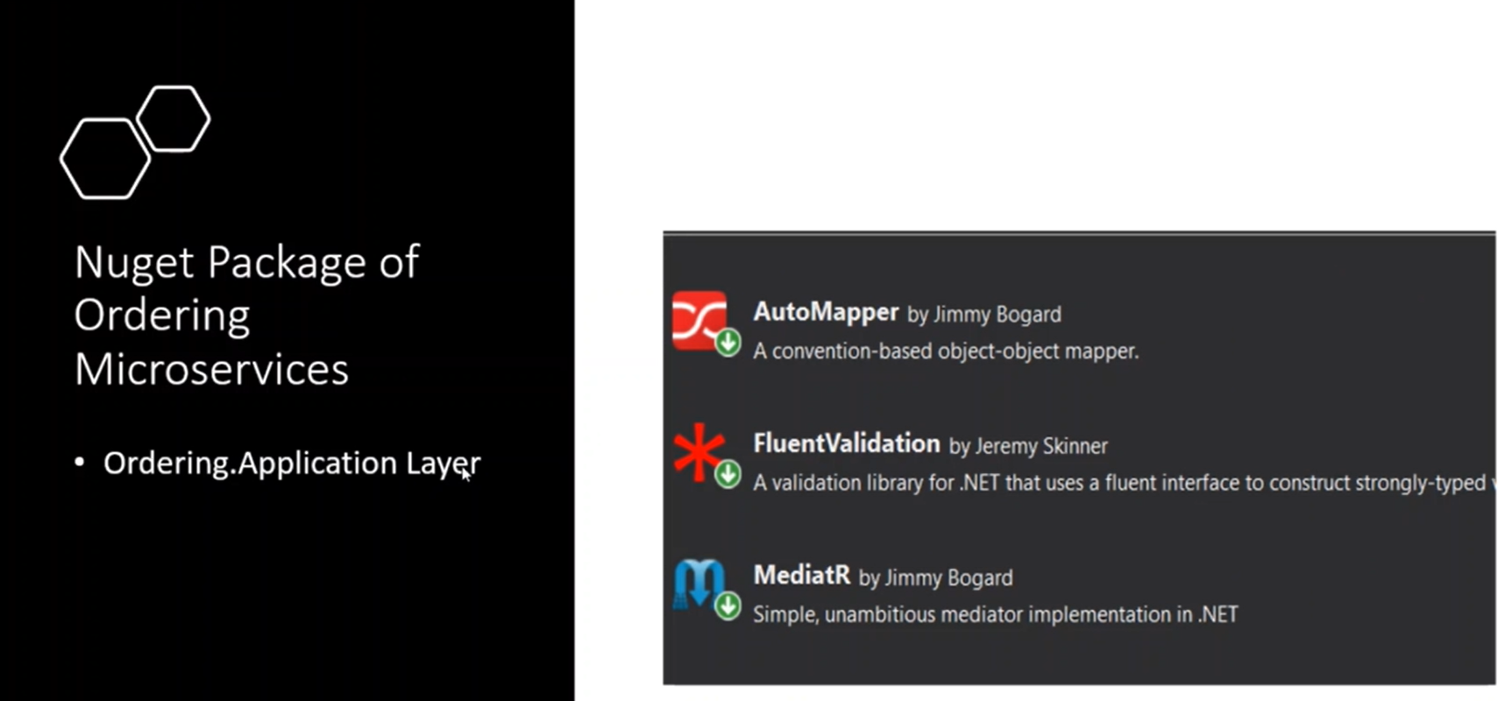

**With using Mediator we apply the CQRS, we can apply separation the command and query objects**

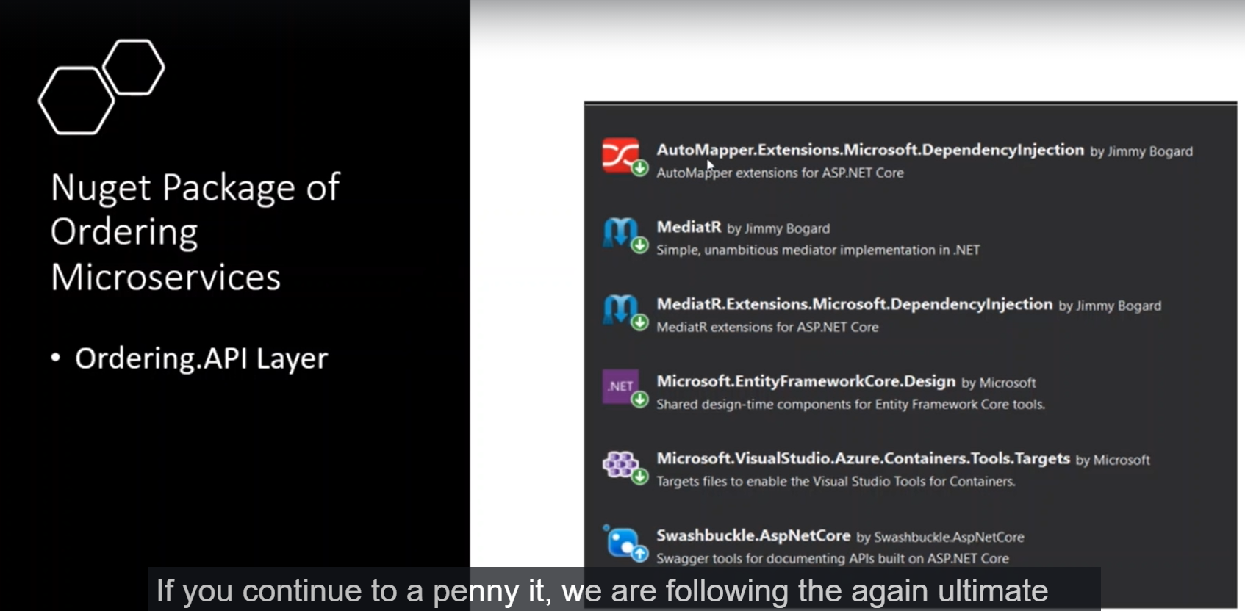

**Lesson07 Code Structure with apply DDD architecture**

**Notes:-**

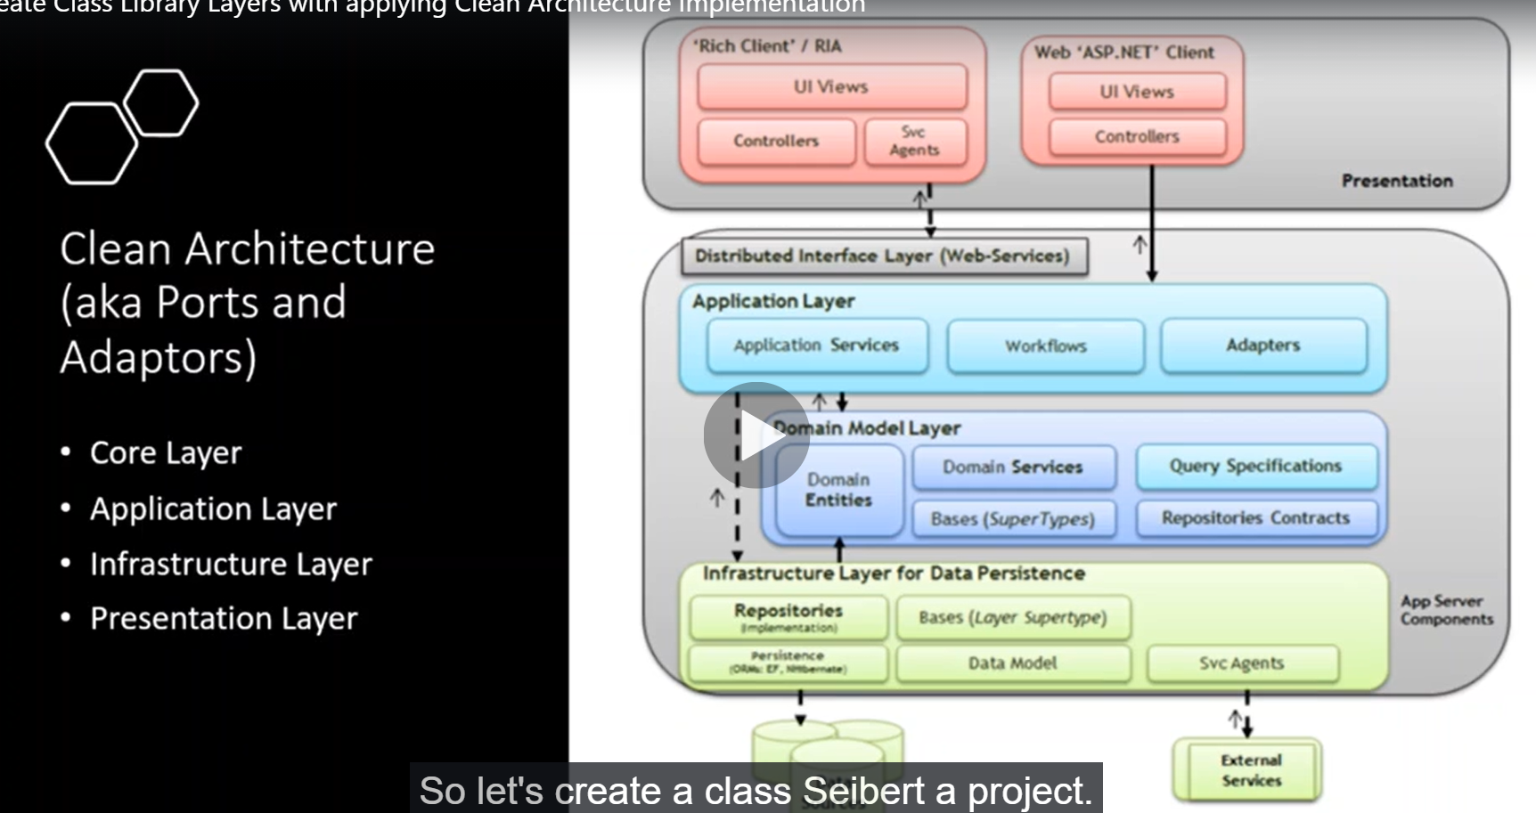

**1-we will implement 4 layer**

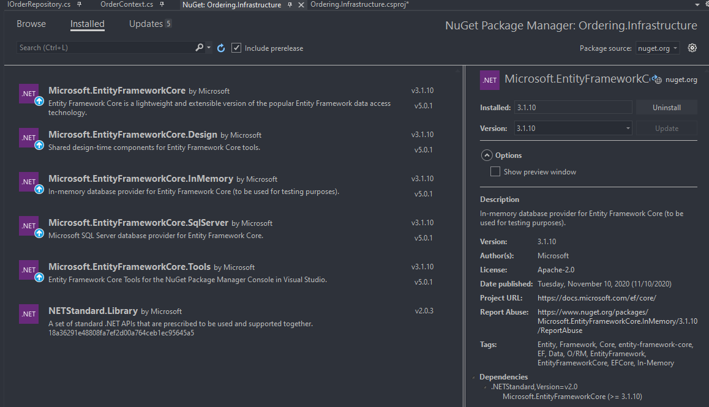

**We go to the docker hub > SQL server and run the following command to download and run container from the image SQL server 2017ubuntu version**

**//we have to make sure the we put the accept_eual which means agree with company conditions //and password to SQL server on the double quotes as below**

**docker run -e "ACCEPT_EULA=Y" -e "SA_PASSWORD=Sw12345678" -p 1433:1433 -d mcr.microsoft.com/mssql/server:2017-CU8-ubuntu**

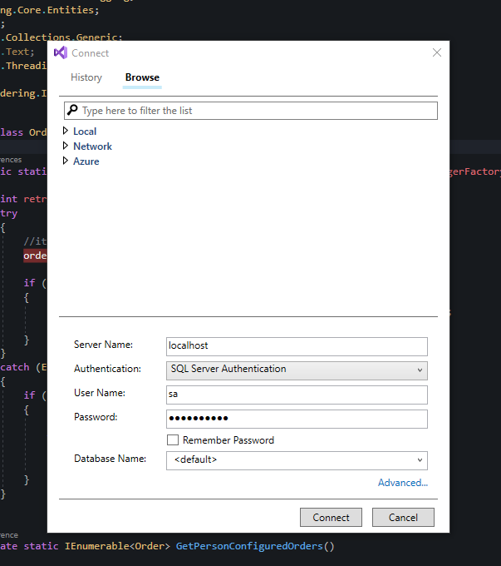

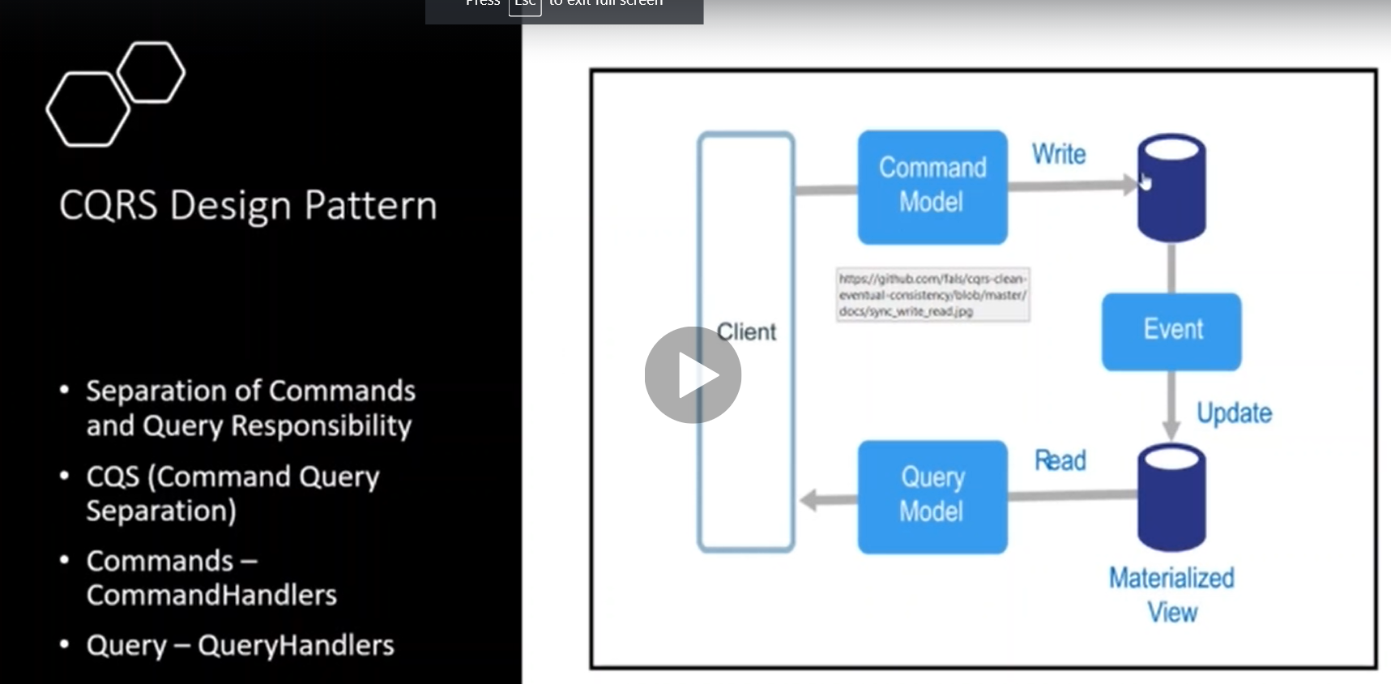

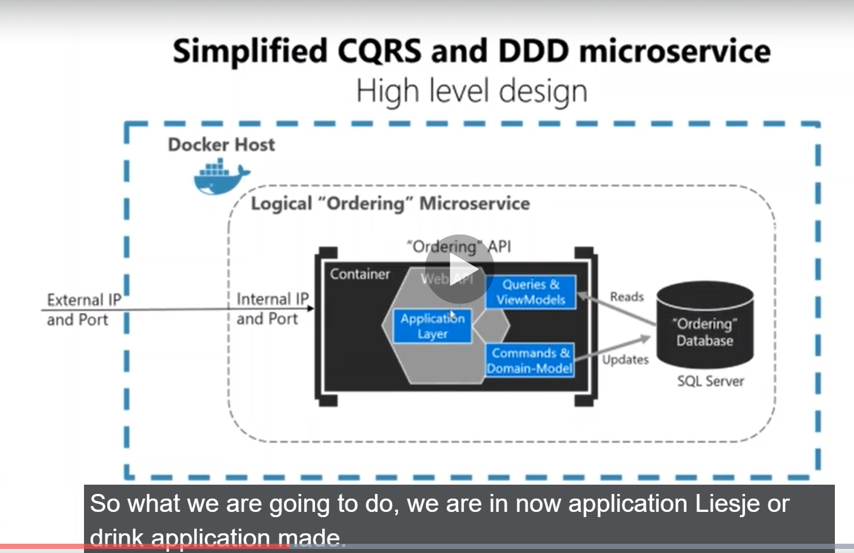

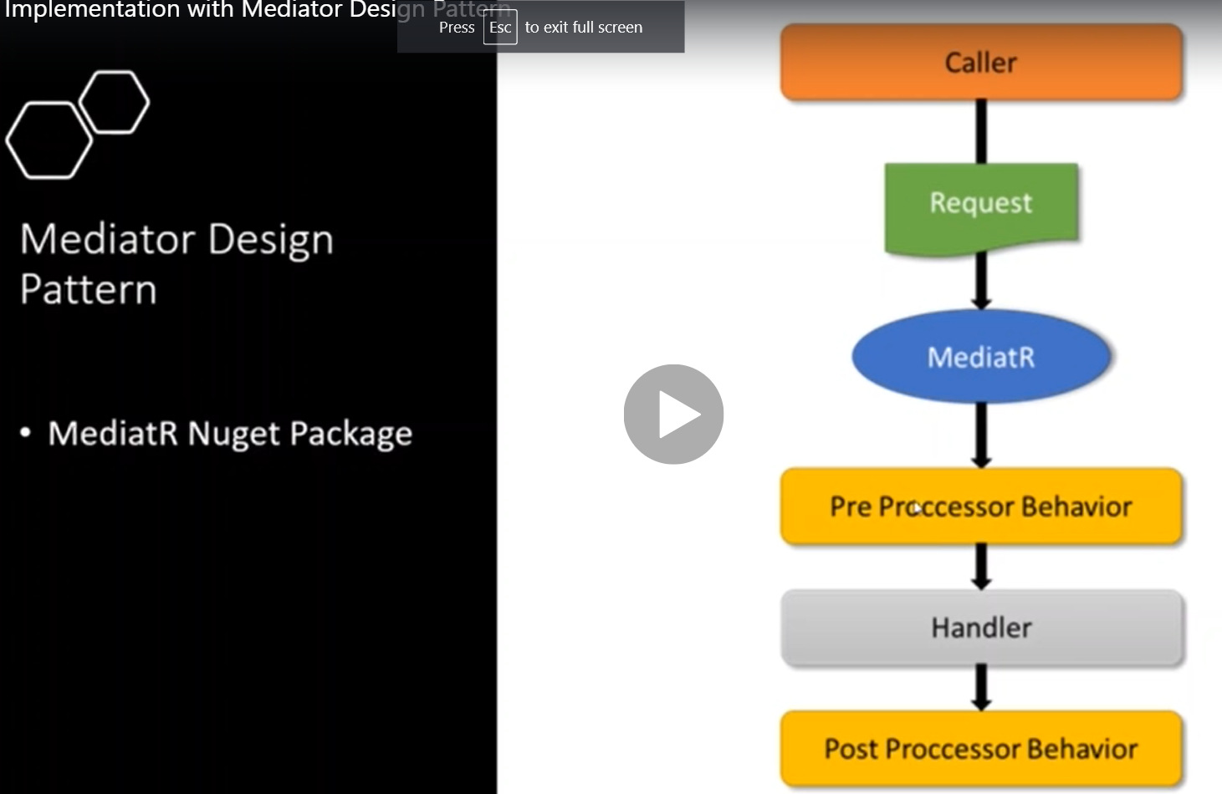

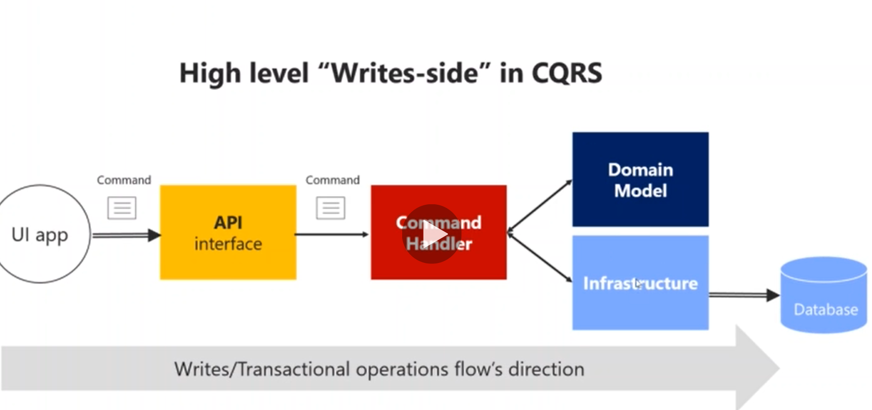

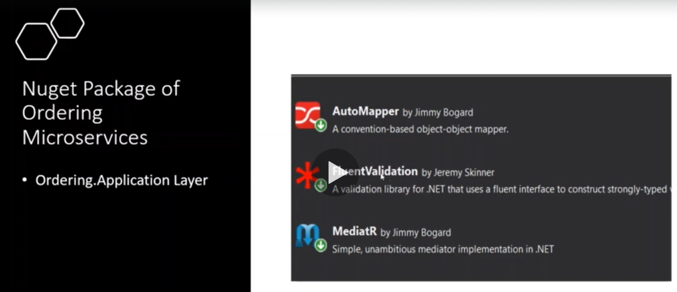

**Steps:-**

**1-we will create 3 class library and web api as below**

**Ordering.Infrastructure : present the ADO operation with the database and depend on the Ordering.Core domain project**

**Ordering.Core : present the domain class and the base class repository that provide the built in functions**

**Ordering.Application : present the CQRS that communicate with the Ordering.API and depends on the Ordering.Core class library**

**A-Ordering.Infrastructure:**

**1-Data > we create class called OrderContext.cs and OrderContextSeed class**

**public class OrderContext : DbContext{**

**public OrderContext(DbContextOptions<OrderContext> options) : base(options){}**

**public DbSet<Order> Orders { get; set; }}**

**public class OrderContextSeed{**

**public static async Task SeedAsync(OrderContext orderContext, ILoggerFactory loggerFactory, int? retry = 0){**

**int retryForAvailability = retry.Value;**

**try{**

**//its useful when you initalize create database and insert the records**

**orderContext.Database.Migrate();**

**if (!await orderContext.Orders.AnyAsync()){**

**await orderContext.Orders.AddRangeAsync(GetPersonConfiguredOrders());**

**await orderContext.SaveChangesAsync();}}**

**catch (Exception ex){**

**if (retryForAvailability < 3){**

**retryForAvailability++;**

**var log = loggerFactory.CreateLogger<OrderContextSeed>();**

**log.LogError(ex.Message);**

**await SeedAsync(orderContext, loggerFactory, retryForAvailability);}}}**

**private static IEnumerable<Order> GetPersonConfiguredOrders(){**

**return new List<Order>(){**

**new Order(){ UserName = "swn",FirstName = "Ali",LastName = "Ahmad",EmailAddress = "ali@hotmail.com",AddressLine = "Amman - Jordan",Country = "Turkey"},**

**new Order(){ UserName = "swr",FirstName = "Isam",LastName = "Ahmad",EmailAddress = "isam@hotmail.com",AddressLine = "Amman - Jordan",Country = "Turkey"},**

**new Order(){ UserName = "swm",FirstName = "Osama",LastName = "Ahmad",EmailAddress = "osama@hotmail.com",AddressLine = "Amman - Jordan",Country = "Turkey"},};}}**

**2-Repositories > Base > Repository that inherit from IRepository from Ordering.Core project**

**public class Repository<T> : IRepository<T> where T : Entity{**

**protected readonly OrderContext _dbContext;**

**public Repository(OrderContext dbContext){**

**_dbContext = dbContext ?? throw new ArgumentNullException(nameof(dbContext));}**

**public async Task<IReadOnlyList<T>> GetAllAsync(){**

**return await _dbContext.Set<T>().ToListAsync();}**

**public async Task<IReadOnlyList<T>> GetAsync(Expression<Func<T, bool>> predicate){**

**return await _dbContext.Set<T>().Where(predicate).ToListAsync();}**

**public async Task<IReadOnlyList<T>> GetAsync(Expression<Func<T, bool>> predicate = null, Func<IQueryable<T>, IOrderedQueryable<T>> orderBy = null, string includeString = null, bool diableTracking = true){**

**IQueryable<T> query = _dbContext.Set<T>();**

**if (diableTracking)**

**query = query.AsNoTracking();**

**if (!string.IsNullOrWhiteSpace(includeString))**

**query = query.Include(includeString);**

**if (predicate != null)**

**query = query.Where(predicate);**

**if (orderBy != null)**

**return await orderBy(query).ToListAsync();**

**return await query.ToListAsync();}**

**public Task<IReadOnlyList<T>> GetAsync(Expression<Func<T, bool>> predicate = null, Func<IQueryable<T>, IOrderedQueryable<T>> orderBy = null, List<Expression<Func<T, object>>> includes = null, bool diableTracking = true){throw new NotImplementedException();}**

**public async Task<T> GetByIdAsync(int id){return await _dbContext.Set<T>().FindAsync(id);}**

**public async Task<T> AddAsync(T entity){**

**_dbContext.Set<T>().Add(entity);**

**await _dbContext.SaveChangesAsync();**

**return entity;}**

**public async Task UpdateAsync(T entity){**

**_dbContext.Entry(entity).State = EntityState.Modified;**

**await _dbContext.SaveChangesAsync();}**

**public async Task DeleteAsync(T entity){**

**_dbContext.Set<T>().Remove(entity);**

**await _dbContext.SaveChangesAsync();}}**

**3-we create OrderRepository that inherit from Repository and IOrderRepository**

**public class OrderRepository : Repository<Order> , IOrderRepository{**

**public OrderRepository(OrderContext dbContext) : base(dbContext){}**

**public async Task<IEnumerable<Order>> GetOrdersByUserName(string userName){**

**var orderList = await _dbContext.Orders.Where(o => o.UserName == userName).ToListAsync();**

**return orderList;}}**

**B-Ordering.Core:**

**1-on the Repositories > Base > create interface IRepository**

**public interface IRepository<T> where T : Entity{**

**Task<IReadOnlyList<T>> GetAllAsync();**

**Task<IReadOnlyList<T>> GetAsync(Expression<Func<T, bool>> predicate);**

**Task<IReadOnlyList<T>> GetAsync(Expression<Func<T, bool>> predicate = null,**

**Func<IQueryable<T>, IOrderedQueryable<T>> orderBy = null,**

**string includeString = null,**

**bool diableTracking = true);**

**Task<IReadOnlyList<T>> GetAsync(Expression<Func<T, bool>> predicate = null,**

**Func<IQueryable<T>, IOrderedQueryable<T>> orderBy = null,**

**List<Expression<Func<T,object>>> includes = null,**

**bool diableTracking = true);**

**Task<T> GetByIdAsync(int id);**

**Task<T> AddAsync(T entity);**

**Task UpdateAsync(T entity);**

**Task DeleteAsync(T entity);}**

**public interface IOrderRepository : IRepository<Order>{**

**Task<IEnumerable<Order>> GetOrdersByUserName(string userName);}**

**2-Entities > Base > we create three classes IEntityBase which contains Id and EntityBase and Entity class which inherit from EntityBase and order class**

**public interface IEntityBase<T>{T Id { get; set; }}**

**public abstract class EntityBase<T> : IEntityBase<T>{**

**public virtual T Id { get; set; }**

**int? _requestHashCode;**

**public bool IsTransient(){return Id.Equals(default(T));}**

**public override bool Equals(object obj){**

**if (obj == null || (obj is EntityBase<T>))**

**return false;**

**if (ReferenceEquals(this, obj))**

**return true;**

**if (GetType() != obj.GetType())**

**return false;**

**var item = (EntityBase<T>)obj;**

**if (item.IsTransient() || IsTransient())**

**return false;**

**else**

**return item == this;}**

**public override int GetHashCode(){**

**if (!IsTransient()){**

**if (!_requestHashCode.HasValue)**

**_requestHashCode = Id.GetHashCode();**

**return _requestHashCode.Value;}**

**else**

**return base.GetHashCode();}**

**public static bool operator ==(EntityBase<T> left,EntityBase<T> right){**

**if (Equals(left, null))**

**return Equals(right, null) ? true : false;**

**else**

**return left.Equals(right);}**

**public static bool operator !=(EntityBase<T> left, EntityBase<T> right){**

**return !(left == right);}}**

**//create class called Entity inherit from EntityBase**

**public abstract class Entity : EntityBase<int>{}**

**//create class called Order which inherit from Entity class**

**public class Order : Entity{**

**public string UserName { get; set; }**

**public decimal TotalPrice { get; set; }**

**//BilingAddress**

**public string FirstName { get; set; }**

**public string LastName { get; set; }**

**public string EmailAddress { get; set; }**

**public string AddressLine { get; set; }**

**public string Country { get; set; }**

**public string State { get; set; }**

**public string ZipCode { get; set; }**

**//Payment**

**public string CardName { get; set; }**

**public string CardNumber { get; set; }**

**public string Expiration { get; set; }**

**public string CVV { get; set; }**

**public int PaymentMethod { get; set; }}**

**C-Order.Application**

**1-Commands > create class called CheckoutOrderCommand**

**public class CheckoutOrderCommand : IRequest<OrderResponse>{**

**public string UserName { get; set; }**

**public decimal TotalPrice { get; set; }**

**// BillingAddress**

**public string FirstName { get; set; }**

**public string LastName { get; set; }**

**public string EmailAddress { get; set; }**

**public string AddressLine { get; set; }**

**public string Country { get; set; }**

**public string State { get; set; }**

**public string ZipCode { get; set; }**

**// Payment**

**public string CardName { get; set; }**

**public string CardNumber { get; set; }**

**public string Expiration { get; set; }**

**public string CVV { get; set; }**

**public int PaymentMethod { get; set; }}**

**2-Quries > create class called GetOrderByUserNamQuery**

**public class GetOrderByUserNameQuery : IRequest<IEnumerable<OrderResponse>>{**

**public string UserName { get; set; }**

**public GetOrderByUserNameQuery(string userName){**

**UserName = userName ?? throw new ArgumentNullException(nameof(userName));}}**

**3-Responses : create response order**

**public class OrderResponse{**

**public int Id { get; set; }**

**public string UserName { get; set; }**

**public decimal TotalPrice { get; set; }**

**//BilingAddress**

**public string FirstName { get; set; }**

**public string LastName { get; set; }**

**public string EmailAddress { get; set; }**

**public string AddressLine { get; set; }**

**public string Country { get; set; }**

**public string State { get; set; }**

**public string ZipCode { get; set; }**

**//Payment**

**public string CardName { get; set; }**

**public string CardNumber { get; set; }**

**public string Expiration { get; set; }**

**public string CVV { get; set; }**

**public int PaymentMethod { get; set; }}**

**4-Mapper >create OrderMapper which present the global configuration of auto mapper as below**

**public static class OrderMapper{**

**private static readonly Lazy<IMapper> Lazy = new Lazy<IMapper>(() =>{**

**var config = new MapperConfiguration(cfg => {**

**cfg.ShouldMapProperty = p => p.GetMethod.IsPublic || p.GetMethod.IsAssembly;**

**cfg.AddProfile<OrderMappingProfile>();});**

**var mapper = config.CreateMapper();**

**return mapper;});**

**public static IMapper Mapper => Lazy.Value;}**

**public class OrderMappingProfile : Profile{**

**public OrderMappingProfile(){**

**CreateMap<Order, OrderResponse>().ReverseMap();**

**CreateMap<Order, CheckoutOrderCommand>().ReverseMap();}}**

**5-Handlers > create two classes of the CheckoutOrderHandler and GetOrderByUserNameHandler**

**public class CheckoutOrderHandler : IRequestHandler<CheckoutOrderCommand, OrderResponse>{**

**private readonly IOrderRepository _orderRepository;**

**public CheckoutOrderHandler(IOrderRepository orderRepository){**

**_orderRepository = orderRepository ?? throw new ArgumentNullException(nameof(orderRepository));}**

**public async Task<OrderResponse> Handle(CheckoutOrderCommand request, CancellationToken cancellationToken){**

**var orderEntity = OrderMapper.Mapper.Map<Order>(request);**

**if (orderEntity == null){throw new ApplicationException("not mapped");}**

**var newOrder = await _orderRepository.AddAsync(orderEntity);**

**var orderResposne = OrderMapper.Mapper.Map<OrderResponse>(newOrder);**

**return orderResposne;}}**

**public class GetOrderByUserNameHandler : IRequestHandler<GetOrderByUserNameQuery, IEnumerable<OrderResponse>>{**

**private readonly IOrderRepository _orderRepository;**

**public GetOrderByUserNameHandler(IOrderRepository orderRepository){**

**_orderRepository = orderRepository ?? throw new ArgumentNullException(nameof(orderRepository));}**

**public async Task<IEnumerable<OrderResponse>> Handle(GetOrderByUserNameQuery request, CancellationToken cancellationToken){**

**var orderList = await _orderRepository.GetOrdersByUserName(request.UserName);**

**var orderResponseList = OrderMapper.Mapper.Map<IEnumerable<OrderResponse>>(orderList);**

**return orderResponseList;}}**

**D-Order.API**

**1-we configure the appsetttings.json as below**{

"ConnectionStrings": {

"OrderConnection": "Server=localhost;Database=OrderDb;User Id=sa;Password=SwN12345678;"},

"EventBus": {

"HostName": "localhost",

"UserName": "guest",

"Password": "guest"},

"Logging": {

"LogLevel": {

"Default": "Information",

"Microsoft": "Warning",

"Microsoft.Hosting.Lifetime": "Information"}},

"AllowedHosts": "*"}

**2-we startup.cs we configure the service bus and the OrderAPI SQL database and apply DI for the IRepository and IOrderRepository and apply AutoMapper and inject Mediator**

**public class Startup{**

**public Startup(IConfiguration configuration){Configuration = configuration;}**

**public IConfiguration Configuration { get; }**

**// This method gets called by the runtime. Use this method to add services to the container.**

**public void ConfigureServices(IServiceCollection services){**

**services.AddControllers();**

**services.AddDbContext<OrderContext>(c => c.UseSqlServer(Configuration.GetConnectionString("OrderConnection")),**

**ServiceLifetime.Singleton);**

**//for the Mediator DI IRepository**

**services.AddScoped(typeof(IRepository<>), typeof(Repository<>));**

**services.AddScoped(typeof(IOrderRepository), typeof(OrderRepository));**

**//for the RabbitMQ listening to the new message**

**services.AddTransient<IOrderRepository, OrderRepository>();**

**//to inject the AutoMapper**

**services.AddAutoMapper(typeof(Startup));**

**//important note : the register of mediator must happen after register the repository and IOrderRepository**

**//to inject the Assembly the refer to the CheckoutOrderHandler in the OrderingAPI to apply DI for the Handlers and Mediator**

**services.AddMediatR(typeof(CheckoutOrderHandler).GetTypeInfo().Assembly);**

**//we create the interface IRabbitMQConnection that inject into the RabbimtMQConnection with pass**

**//DI of the IConnectionFactory to apply DI for the IConnection Factory**

**services.AddSingleton<IRabbitMQConnection>(sp => {**

**var factory = new ConnectionFactory(){**

**HostName = Configuration["EventBus:HostName"]};**

**if (!string.IsNullOrEmpty(Configuration["EventBus:UserName"])){**

**factory.UserName = Configuration["EventBus:UserName"];}**

**if (!string.IsNullOrEmpty(Configuration["EventBus:Password"])){**

**factory.UserName = Configuration["EventBus:Password"];}**

**return new RabbitMQConnection(factory);});**

**//we register the EventBusRabbitMQConsumer**

**services.AddSingleton<EventBusRabbitMQConsumer>();**

**services.AddSwaggerGen(c =>{**

**c.SwaggerDoc("v1", new OpenApiInfo { Title = "Ordering.API", Version = "v1" });});}**

**// This method gets called by the runtime. Use this method to configure the HTTP request pipeline.**

**public void Configure(IApplicationBuilder app, IWebHostEnvironment env){**

**if (env.IsDevelopment()){**

**app.UseDeveloperExceptionPage();**

**app.UseSwagger();**

**app.UseSwaggerUI(c => c.SwaggerEndpoint("/swagger/v1/swagger.json", "Ordering.API v1"));}**

**app.UseRouting();**

**//we make extension method that will pass IApplicaitonBuilder as argument and it will register two events**

**//1-for started event call the consume method**

**//2-for stopping disconnect the EventBusRabbitMQConsumer by dispose the IRabbitMQConnection connection**

**app.UserRabbitListener();**

**app.UseAuthorization();**

**app.UseEndpoints(endpoints =>{endpoints.MapControllers();});}}**

**3-on the program.cs we inject logger and seeder**

**public class Program{**

**public static void Main(string[] args){**

**var host = CreateHostBuilder(args).Build();**

**CreateAndSeedDatabase(host).GetAwaiter().GetResult();**

**host.Run();}**

**public static IHostBuilder CreateHostBuilder(string[] args) =>**

**Host.CreateDefaultBuilder(args)**

**.ConfigureWebHostDefaults(webBuilder =>{webBuilder.UseStartup<Startup>();});**

**//we must add reference to all the class libraries becouse its the upper layer**

**private static async Task CreateAndSeedDatabase(IHost host){**

**//to access to orderContext**

**using (var scope = host.Services.CreateScope()){**

**var services = scope.ServiceProvider;**

**//it will internally called DI to crate ILogger Factory**

**var loggerFactory = services.GetRequiredService<ILoggerFactory>();**

**try{**

**var orderContext = services.GetRequiredService<OrderContext>();**

**await OrderContextSeed.SeedAsync(orderContext, loggerFactory);}**

**catch(Exception ex){**

**var logger = loggerFactory.CreateLogger<Program>();**

**logger.LogError(ex.Message);}}}}**

**4-on the Mapping > OrderMapping**

**public class OrderMapping : Profile{**

**public OrderMapping(){**

**CreateMap<BasketCheckoutEvent, CheckoutOrderCommand>().ReverseMap();}}**

**5-on the RabbitMQ > create class EventBusRabbitMQConsumer**

**public class EventBusRabbitMQConsumer{**

**private readonly IRabbitMQConnection _connection;**

**private readonly IMediator _mediator;**

**private readonly IMapper _maper;**

**private readonly IOrderRepository _repository;**

**public EventBusRabbitMQConsumer(IRabbitMQConnection connection, IMediator mediator, IMapper maper, IOrderRepository repository){**

**_connection = connection ?? throw new ArgumentNullException(nameof(connection));**

**_mediator = mediator ?? throw new ArgumentNullException(nameof(_mediator));**

**_maper = maper ?? throw new ArgumentNullException(nameof(_maper));**

**_repository = repository ?? throw new ArgumentNullException(nameof(_repository));}**

**//it will create new channel**

**public void Consume(){**

**var channel = _connection.CreateModel();**

**channel.QueueDeclare(queue: EventBusConstants.BasketCheckoutQueue, durable: false, exclusive: false, autoDelete: false, arguments:null);**

**var consumer = new EventingBasicConsumer(channel);**

**consumer.Received += ReceivedEvent;**

**channel.BasicConsume(queue: EventBusConstants.BasketCheckoutQueue, autoAck: true, consumer: consumer,noLocal:false,exclusive:false,arguments:null);}**

**public async void ReceivedEvent(object sender, BasicDeliverEventArgs e){**

**if (e.RoutingKey == EventBusConstants.BasketCheckoutQueue){**

**var message = Encoding.UTF8.GetString(e.Body.Span);**

**var basketCheckoutEvent = JsonConvert.DeserializeObject<BasketCheckoutEvent>(message);**

**var command = _maper.Map<CheckoutOrderCommand>(basketCheckoutEvent);**

**await _mediator.Send(command);}}**

**public void Disconnect(){_connection.Dispose();}}**

**6-on the Extensions > ApplicationBuilderExtensions its helper class that used to inject and consume the RabbitMQ**

**//when the application start we register two event onStarted , onStopping which onStarted will call Consume which**

**//appear on the EventRabbitMQConsumer.cs**

**public static class ApplicationBuilderExtensions{**

**public static EventBusRabbitMQConsumer Listener { get; set; }**

**public static IApplicationBuilder UserRabbitListener(this IApplicationBuilder app){**

**Listener = app.ApplicationServices.GetService<EventBusRabbitMQConsumer>();**

**var life = app.ApplicationServices.GetService<IHostApplicationLifetime>();**

**life.ApplicationStarted.Register(onStarted);**

**life.ApplicationStopping.Register(OnStopping);**

**return app;}**

**private static void onStarted(){Listener.Consume();}**

**private static void OnStopping(){Listener.Disconnect();}}**

**7-on the Controller > OrderController**

**[ApiController]**

**[Route("api/v1/[controller]")]**

**public class OrderController : ControllerBase{**

**//we inject mediator in order to communicate between Handler and queries or commands**

**private readonly IMediator _mediator;**

**public OrderController(IMediator mediator){**

**_mediator = mediator ?? throw new ArgumentNullException(nameof(mediator));}**

**[HttpGet]**

**[ProducesResponseType(typeof(IEnumerable<OrderResponse>), (int)HttpStatusCode.OK)]**

**public async Task<ActionResult<IEnumerable<OrderResponse>>> GetOrdersByUserName(string userName){**

**var query = new GetOrderByUserNameQuery(userName);**

**//it will take the query GetOrderByUserNameQuery that return to the handler that use the query class as parameter request**

**//which is the GetOrderByUserNameHandler and then it will send the request and return the response**

**var orders = await _mediator.Send(query);**

**return Ok(orders);}**

**//testing purpose**

**[HttpPost]**

**[ProducesResponseType(typeof(OrderResponse), (int)HttpStatusCode.OK)]**

**public async Task<ActionResult<OrderResponse>> CheckoutOrder([FromBody] CheckoutOrderCommand command){**

**//becouse the CheckoutOrderCommand not contain parameter we can simply pass the CheckOrderCommand to the mediator**

**//to investigate which handler belong to and apply the operation**

**var result = await _mediator.Send(command);**

**return Ok(result);}}**